Your Name here

[Draw your reader in with an engaging abstract. It is typically a short summary of the document. When you’re ready to add your content, just click here and start typing.]
[Document title]
Computer Science NEA

Contents
Feedback 2
Design updates 3

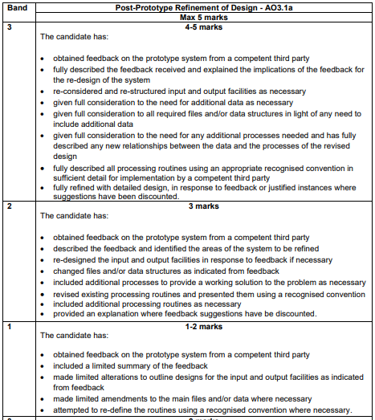
This is for your reference only and needs to be deleted when it is handed in as a final copy.

Please also delete any of my comments from the sections below, on final hand in

Feedback
Fully describe the feedback you have received and identify any redesign you need to do to the system. You will have to do something!! You should consider the following
- Any restructured input/output
- Any additional tables or data structures
- Any additional process that you haven’t designed previously.

Design updates
Any change you have identified above must have a design update. Explain how these link with the feedback suggestions made.
You MUST have something in this section!!

